EXPERIMENT 6
EDA – GROUPING AND AGGREGATION
Aim
To perform grouping and aggregation on the Customer Churn dataset using Pandas and analyze customer behavior based on different categories.
Procedure
1. Load the Customer Churn dataset using Pandas.
2. Group customers based on Contract.
3. Calculate the total number of customers in each contract type.
4. Calculate average tenure and average monthly charges for each contract type.
5. Analyze churn based on contract type using a cross-tabulation.
6. Group customers based on InternetService.
7. Calculate total customers and average monthly charges for each internet service type.
8. Create a bar chart to visualize customers by contract type.
9. Display the analysis results.
Python Code
import pandas as pd
import matplotlib.pyplot as plt

# Load dataset
df = pd.read_csv("WA_Fn-UseC_-Telco-Customer-Churn.csv")

# 1. Group by Contract
contract_analysis = df.groupby("Contract").agg(
Total_Customers=("customerID", "count"),
Average_Tenure=("tenure", "mean"),
Average_Monthly_Charges=("MonthlyCharges", "mean")
)

print("Contract Analysis:")
print(contract_analysis)

# 2. Churn analysis by Contract
churn_analysis = pd.crosstab(
df["Contract"],
df["Churn"]
)

print("\nChurn by Contract:")
print(churn_analysis)

# 3. Group by Internet Service
internet_analysis = df.groupby("InternetService").agg(
Total_Customers=("customerID", "count"),
Average_Monthly_Charges=("MonthlyCharges", "mean")
)

print("\nInternet Service Analysis:")
print(internet_analysis)

# 4. Bar chart
contract_analysis["Total_Customers"].plot(
kind="bar"
)

plt.title("Customers by Contract Type")
plt.xlabel("Contract Type")
plt.ylabel("Number of Customers")
plt.xticks(rotation=20)
plt.show()
Code Output
Contract Analysis:
Total_Customers Average_Tenure Average_Monthly_Charges
Contract
Month-to-month 3875 18.036645 66.398490
One year 1473 42.044807 65.048608
Two year 1695 56.735103 60.770413

Churn by Contract:
Churn No Yes
Contract
Month-to-month 2220 1655
One year 1307 166
Two year 1647 48

Internet Service Analysis:
Total_Customers Average_Monthly_Charges
InternetService
DSL 2421 58.102169
Fiber optic 3096 91.500129
No 1526 21.079194
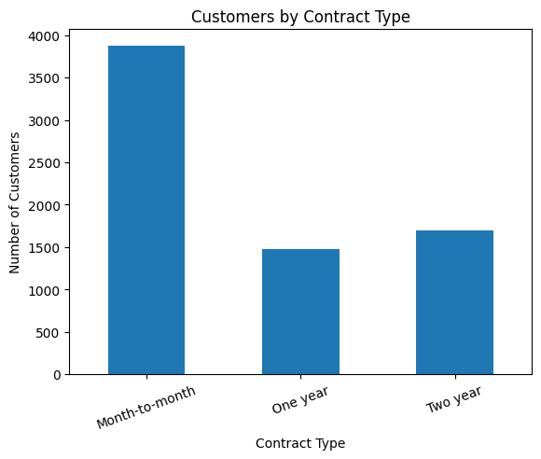

Result
The Customer Churn dataset was successfully grouped and aggregated using Pandas. The analysis identified differences in customer count, average tenure, monthly charges, and churn across contract and internet service types.

